**Fetching changes from GitHub via SSH**

**a**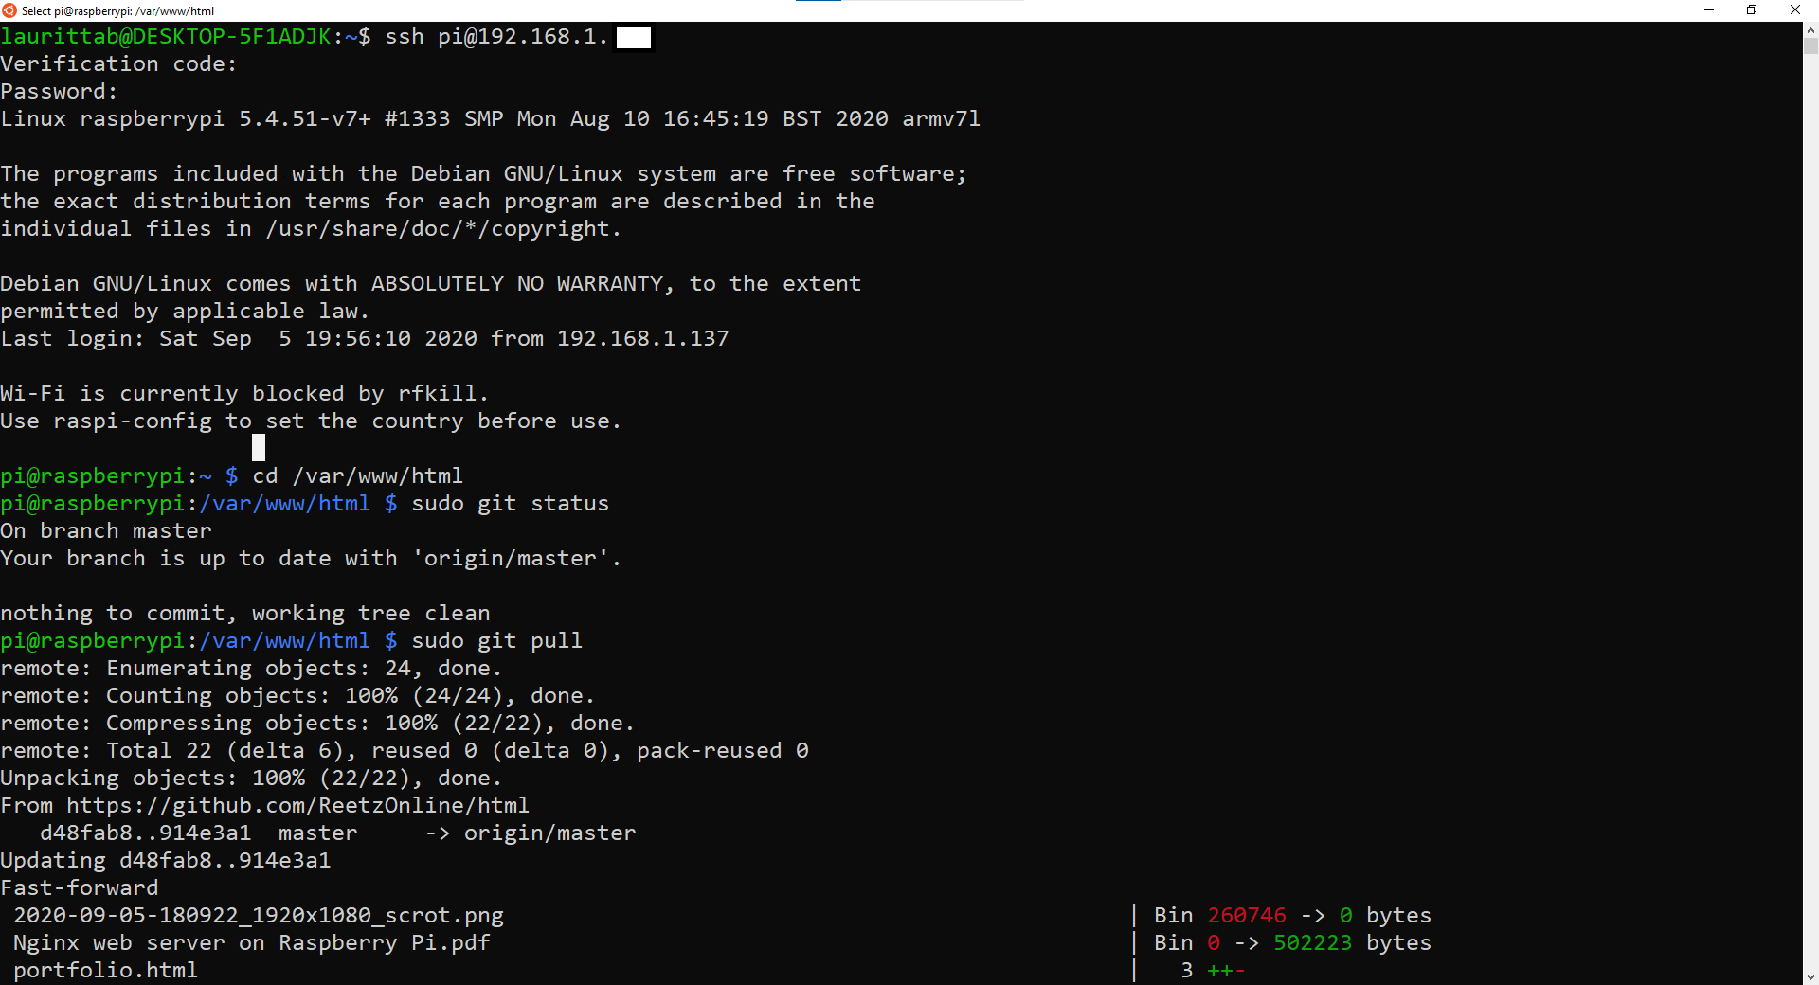

**Changes updated to web server folder**

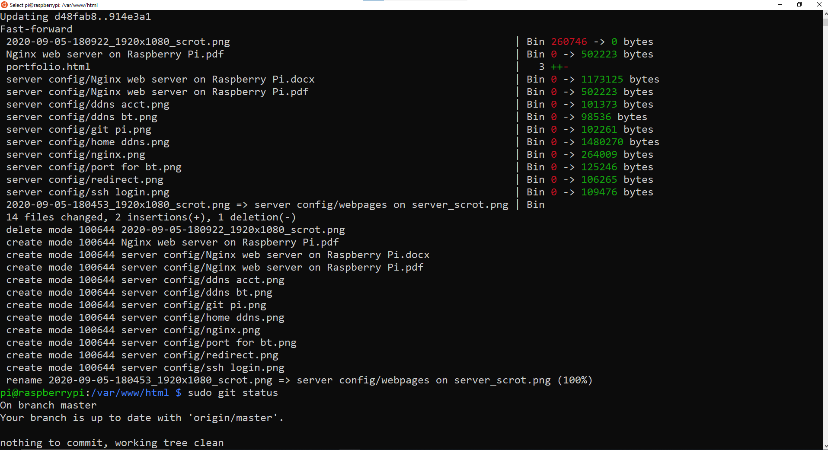

**Moving files into website folder, adding, committing and pushing to GitHub**

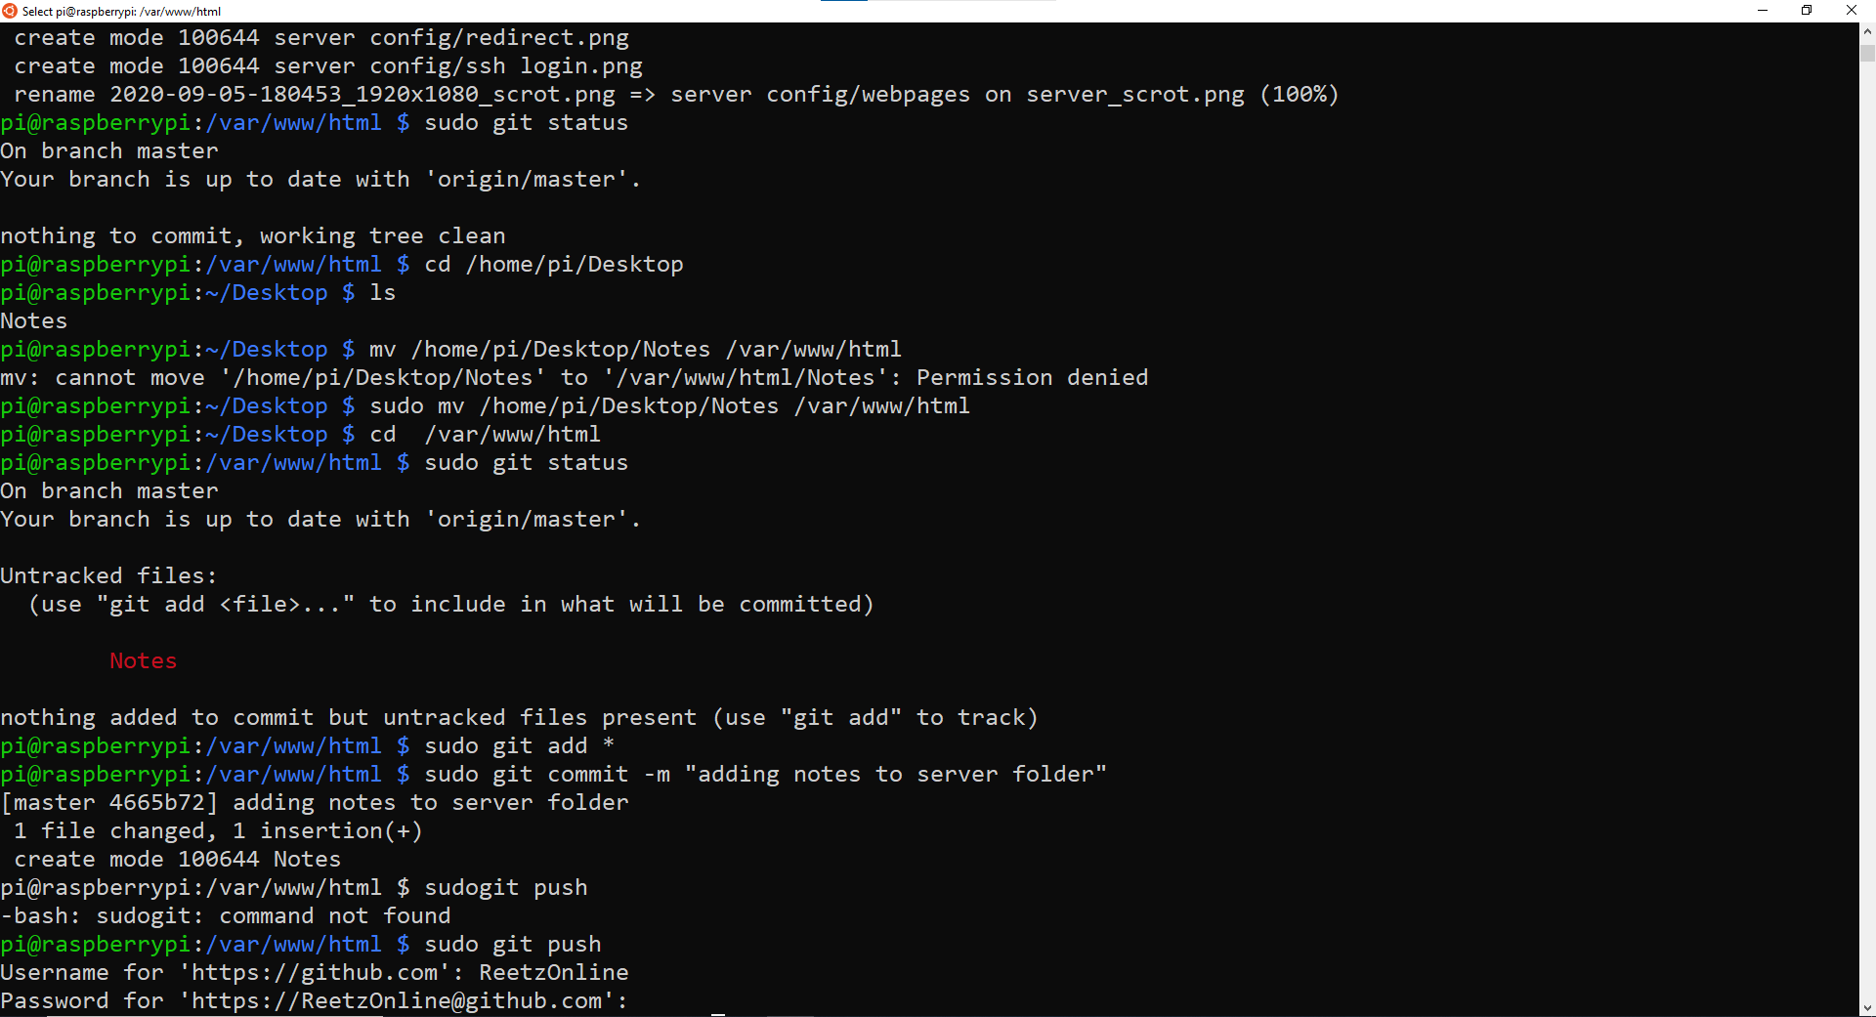

**Changes confirmed as completed**

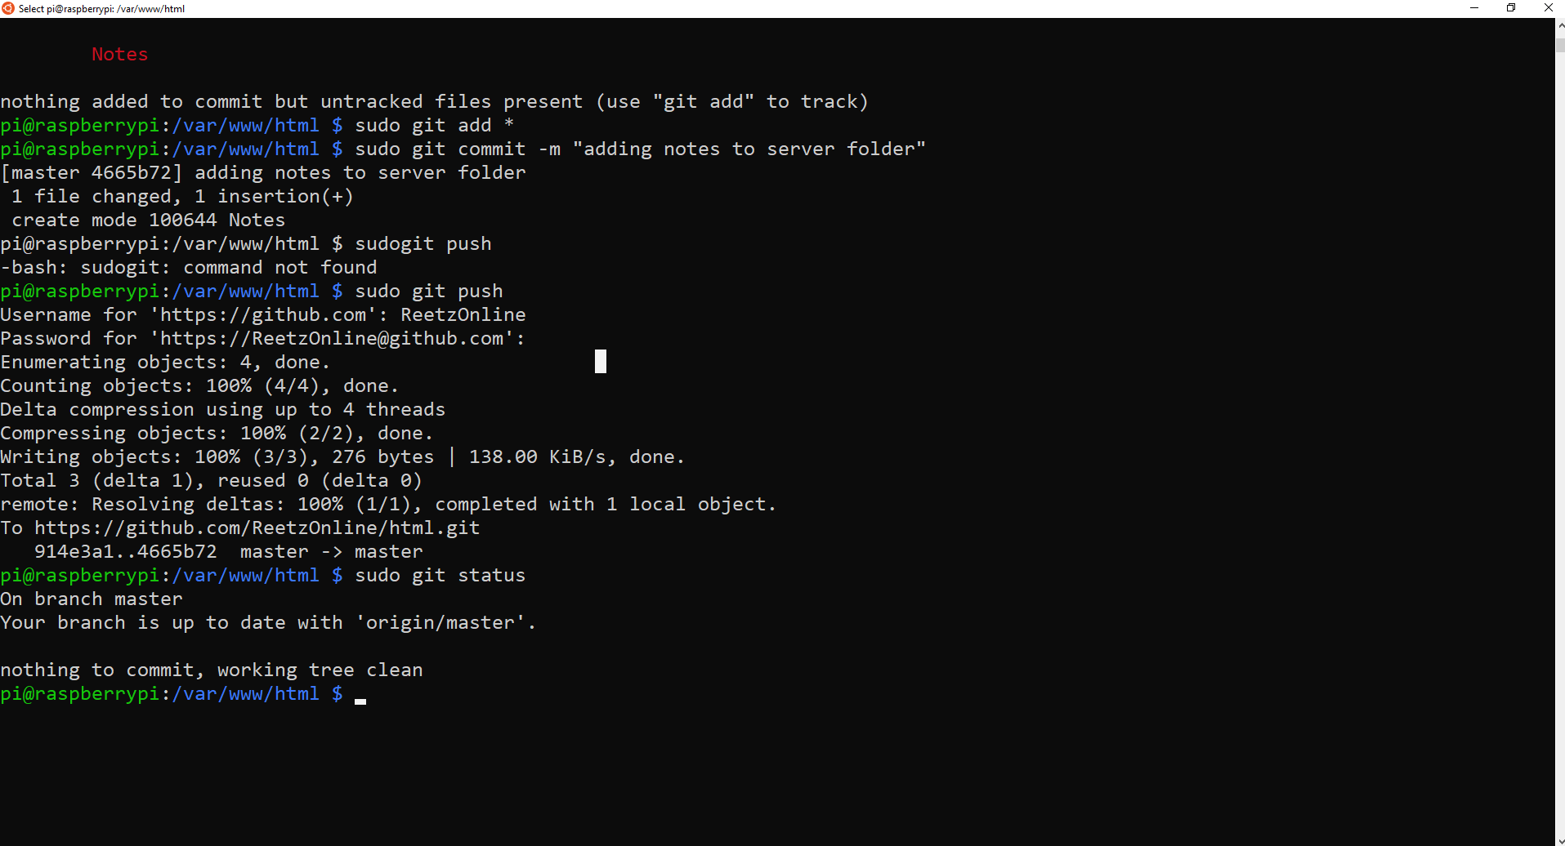

**View from GitHub, ‘Notes’ file confirmed as added to folder**

